Performance Report

Demonstrates the performance of the website has been measured

# Website Performance

The website’s performance was tested using the performance tool in Google Chrome’s Developer tools. The Chrome performance monitor records the website’s performance metrics while the page is running or reloading. The user is able to review and interact with snapshots of recordings. After a recording is taken, a graph is displayed with the summary of the website’s performance.

(BitDegree, 2019)

Home page (index.php)

Running the home page takes a relatively shorter period of time as it does not contain much code, it just contains the design and a few words for now.

1. 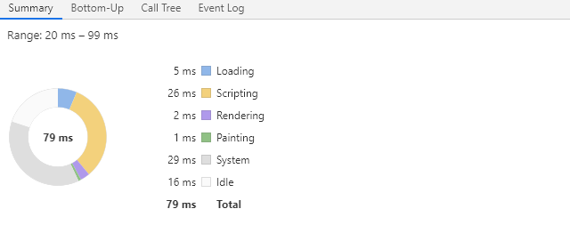

Search page (search.php)

1. According to the graph, rendering the search page takes up most of the time as the website is grabbing all the data from the database in one go and rendering it on the page.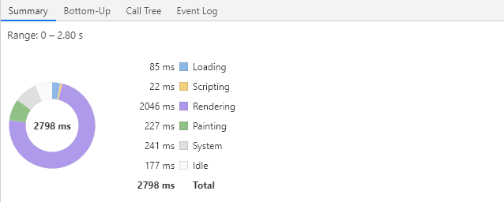
2. When searching, system uses most of the time as it is searching in the database for the information requested

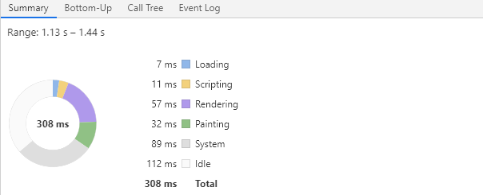

Top 10 Movies page (top10.php)

Scripting takes up most of the time on the top 10 movies page as jQuery and JavaScript is used to display the graph and execution of them takes up time.

1. 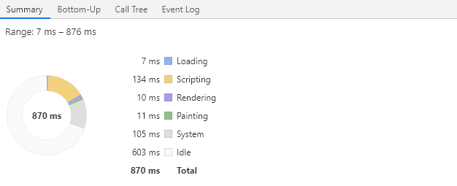

Sign Up page (signup.php)

1. Signing up to the page requires the system to load the data to the database, hence system takes up most of the time here.

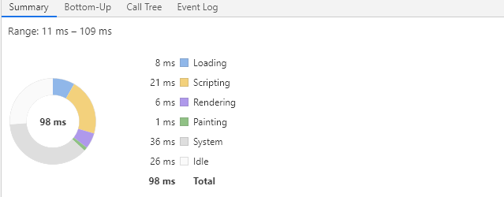

1. Signing up to the page requires the system to save the information to the database, hence, system takes up most of the time

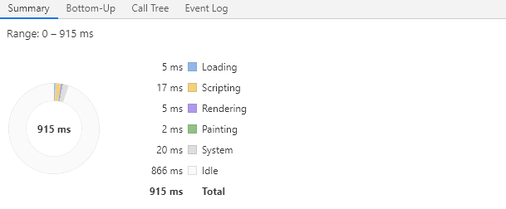

Login page (login.php)

1. Loading the login page doesn’t take up much time as it just contains a few text fields and buttons

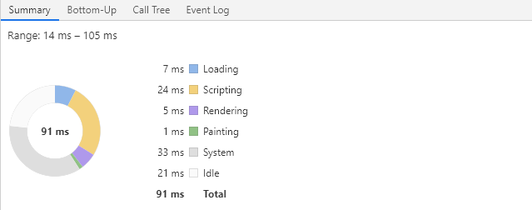

1. When logging in, the system takes up most of the time as it is required to load the database to ensure the credentials inputted are accurate

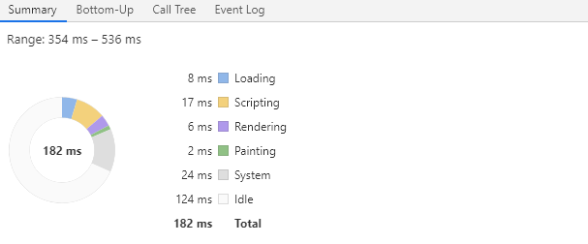

# PHP CodeSniffer

Home page (index.php)

1. 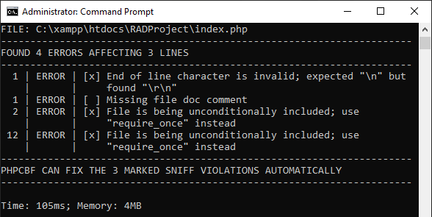
2. 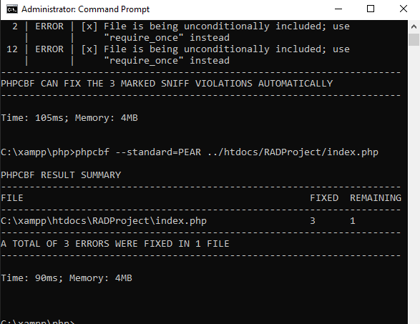

Search page (search.php)

1. 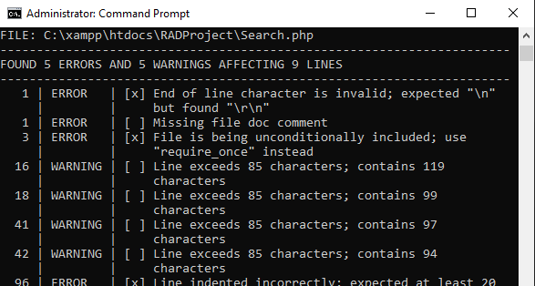
2. 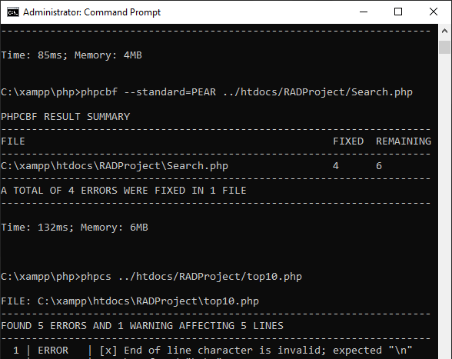

Top 10 Movies page (top10.php)

1. 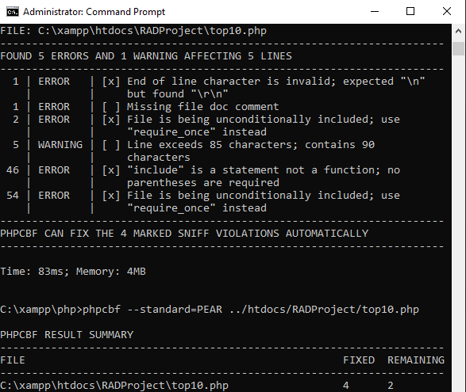
2. 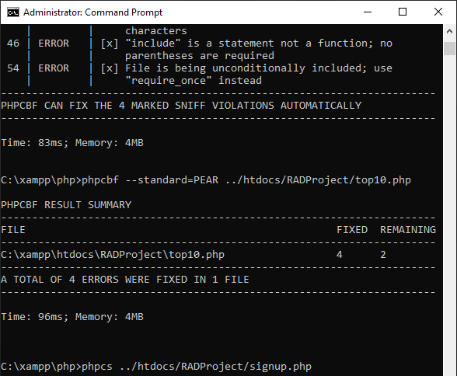

Sign Up page (signup.php)

1. 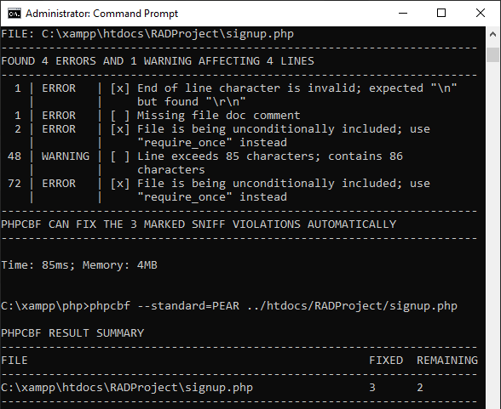
2. 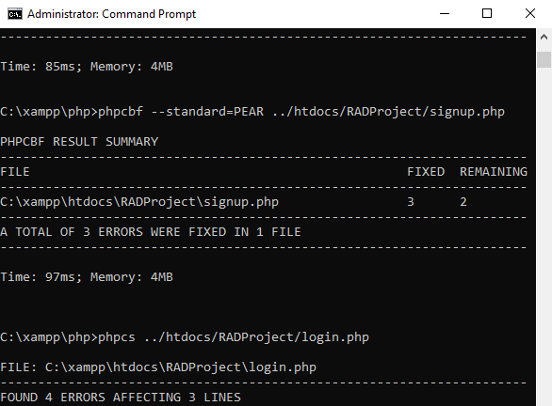

Login page (login.php)

1. 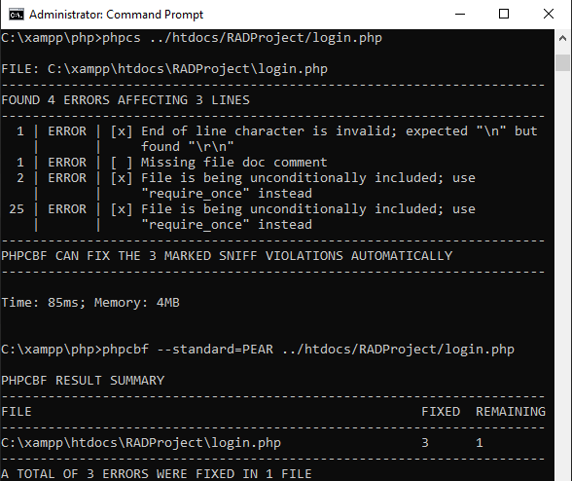
2. 